Calculus 1 Lecture 2.8: Related Rates

Related Rates
How to relate a formula to a change according to time.

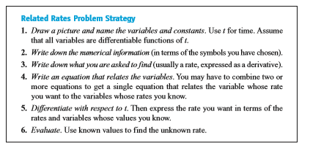
Example
Cone:
Find the Rate of change of the volume of the water
with respect to time
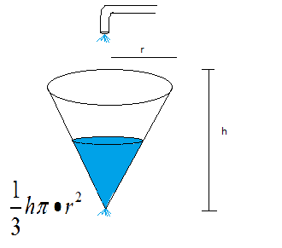

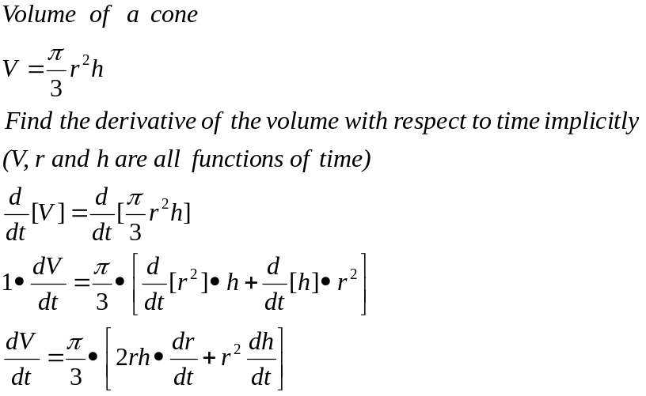

Example
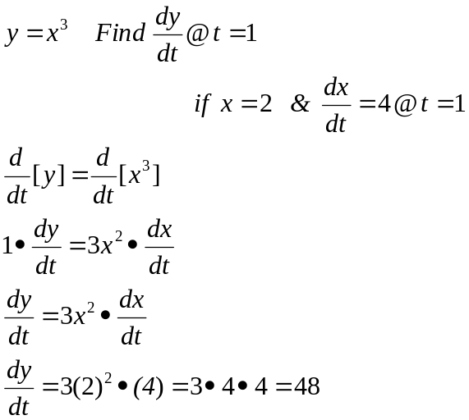

Example
Oil spill:
Radius is spreading at a constant rate of 3ft/sec.
How fast is the area increasing when the radius is 30 feet?
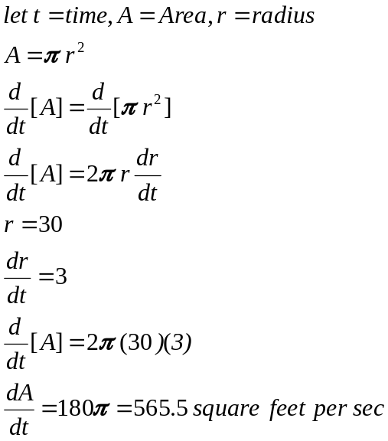

Example
Rocket:
A rocket is climbing at a rate of 600 feet/sec. When the rocket is at 4000 ft. how fast will the
angle of elevation have to change at 4000 ft. to keep up with the rocket. This is being televised

Sides of triangle below is 3000=adj, h=opp=4000, hyp=?
